Systems analysis and design

Name of student

Name of professor

University

Course

Date

**Introduction**

Systems analyst play a big role in implementing the requirements needed by the developers. In summary we can say that systems analysts stand in the gap between software developers and the business. Whereas the business shall design the business requirements, the software developers will have to seat down with software engineers to interpret their technical requirements.

Further, systems analysis being the center of the software engineering, it is prudent to identify the some of the elements comprising the e-cleaning website. To do this, a better and a closer approach has to be taken into looking at the existing architecture of this type of application. The assumption here is that this is an online application.

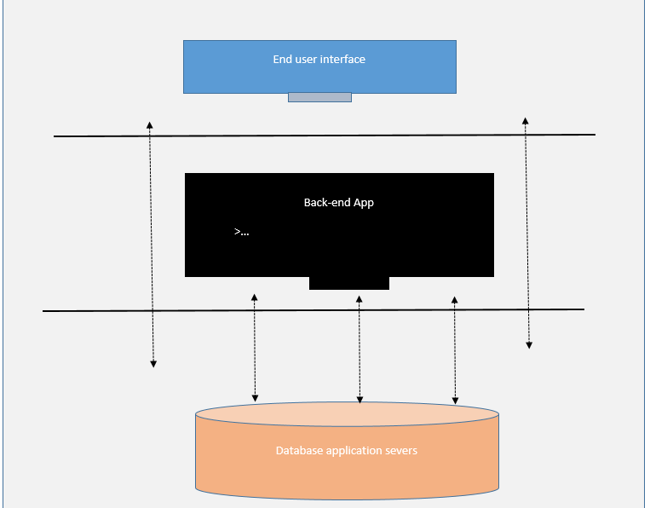

The above architecture is a rough would be view of the way the system is expected to look like. This general overview illustrates that there are three 3 phases when it comes to making this web application, the first phase is the user interface interaction page where the user interacts with the application itself.

The data displayed on this page is derived from the database and that’s why there exists connect between the user interface and the database application. The backed application defines the algorithms and the API calls that are made frequently to the server to get the status of the user objects. In most cases, the backend application is usually just used as a by management and other staff admins to monitor the status performance of the business.

The second phase of the systems analysis design is even more granular, it dissects each and every component of the application and tries to establish what is actually required or would be needed. This architecture can be broke down as follows:

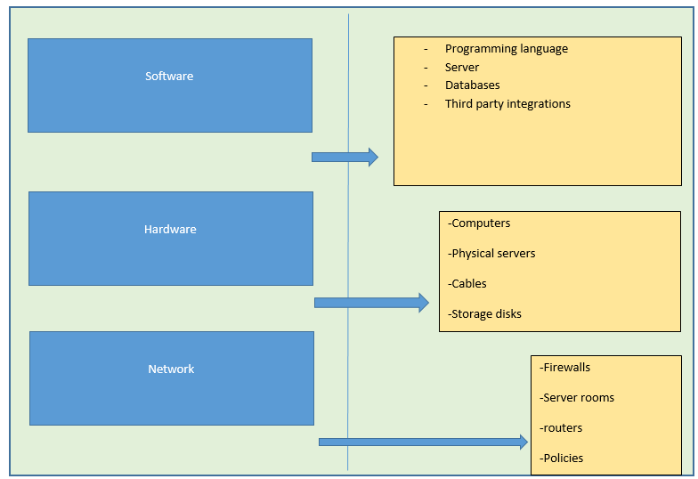

This second phase of analysis tries to break down the details required by the system into smaller bits that then developers and business can understand and be able to act on during the several stages of their development. Since the system in question is that of an e-laundry business, the following are some of the requirements broken down into discussions

**Software:**

Depending on the exercise of the various developer assigned to the project the following programming languages can be adopted:

1. Front end – React Js, Bootstrap, Angular (That comes with JavaScript)
2. Backend – Node Js, Laravel, Spring Boot, Ruby on Rails
3. Database – MySQL, PostgreSQL, Oracle, DB2 or Unstructured
4. Third party integrations – Banking APIs, SMS

However, it should be released the usage and the valuation of each and every programming language depends on the nature of the organization like how many clients it has , the cost that they are willing to spend in coming up with the system and the time projected and needed for the system to be complete.

For instance, systems that are needed within the shortest period of time will most likely take a lot of time to make and design. So other frameworks can influence this particular decisions. The next stage of this is to designs the use case diagram.

**Use case diagram;**

Now that we have established how the elements of the system, it’s important to define the use case using a flow chart diagram, how a typical user will interact with this system. To do this, the systems analyst has to identify which of the user are needed to work on this system.

* End user clients
* System admins
* Database engineers
* Partners and third party

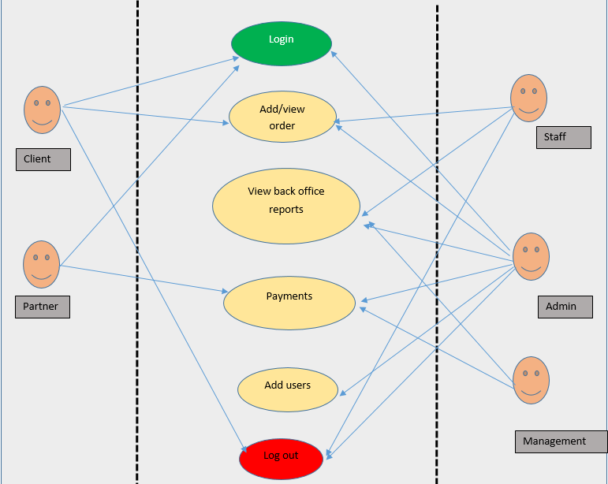

The above use case shows the role based access of the systems. During software development, only the logged in user can view their respective routes. Each and very role id is limited to the number of users who can access it. Since the admin is the overall user of the application, he/she is given the overall rights and access to the system.

The next phase is to define a flow chart design for the e-laundry application

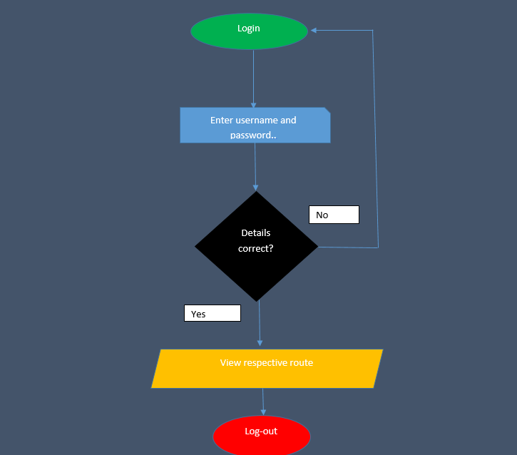

This flow chart illustrates the different processes and actions that will be taken by the systems users when interacting with the application. The first validation check is dig counter check which validation inputs are required, for instance , user name and password must much and where such does not match the user is directed back to the login screen where they have to login again or enter the correct input.

For users who have captured details correctly, they can go ahead and view the correct respective route that they so desire and act on based on the various accessed that have been granted to them. When all is done, they have to log out /exist the application.

**Functional analysis**

In systems analysis and designs, functional analysis describe how each and every user will interact with the system components. In the e-laundry application, the following UI components are responsible for the various functional requirements.

* Buttons
* Events
* Text inputs
* Loaders
* Call to action buttons
* Flash messages

Hence, what functional requirements do is to state what the code should validate to the user and the kind of response that the user should get. These functional requirements speak to bother the software engineer and the end user what is expected of them during system interactivity. The table below summarizes this:

|  |  |  |  |
| --- | --- | --- | --- |
| Component | action | message | Feedback |
| Buttons | Execute logic | Successes/error | Success or show error message |
| Text inputs | Capture key board inputs | Validate input | Show error /validation message |
| Events | Alert user | Display action | Confirm selection |